CI/CD Deployment for SpringBoot Application.

(Source Code)

Version History:

|  |  |
| --- | --- |
| Author | Aman Kumar |
| Purpose | Project Source Code |
| Date | 27/07/2022 |
| Version | 1.0 |

Contents.

1. GitHub Link… 3
2. Flow Chart… 3
3. Folder Structure 5
4. Project Files… 6

# GitHub Link

# https://github.com/amanlogin/Phase-5-CI-CD-Deployment

## Host server app to view the deployed application: http://3.91.182.20:7000/

# Flow Chart

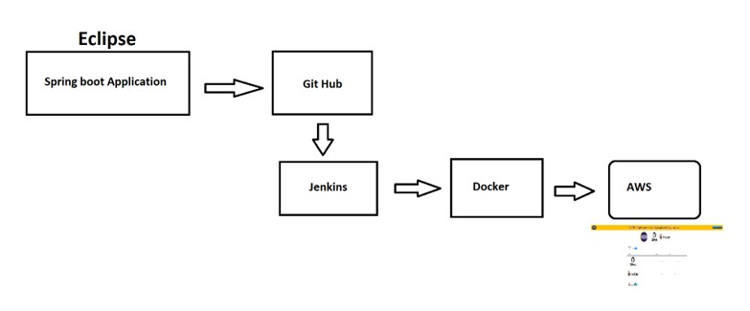

# Folder Structure.

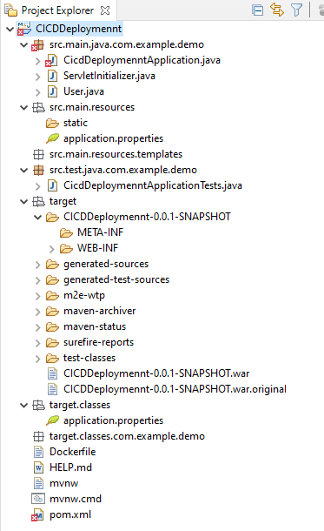

* In Eclipse create a new project by choosing File > New > Spring Starter Project.

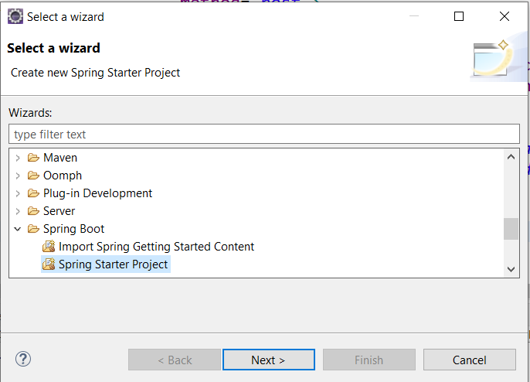

* The Configure your new project as a Spring Web and finish

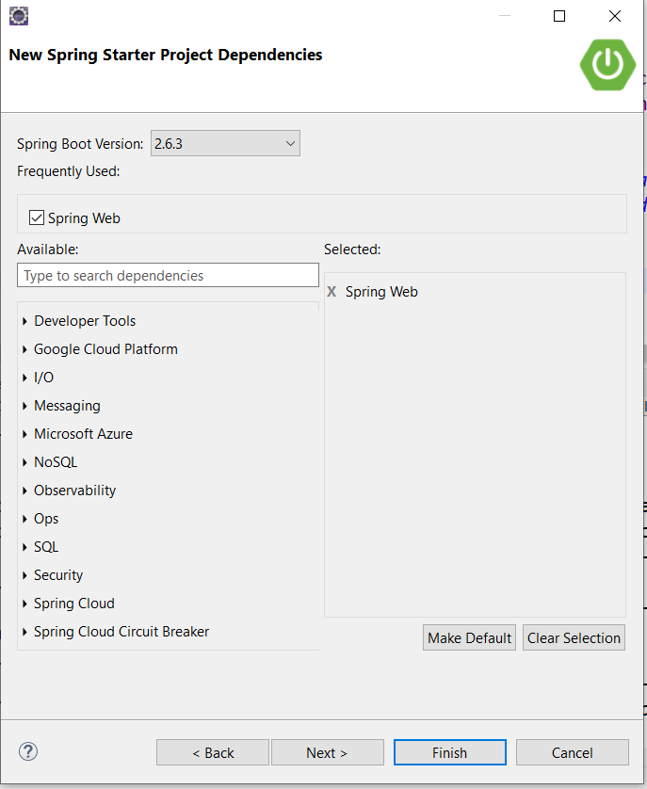

* + After programming the Spring Boot Application using maven to build the WAR file.

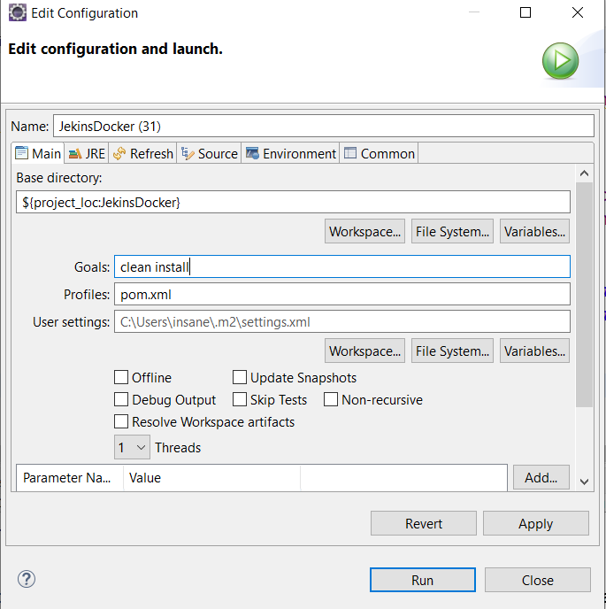

# Project Files.

### **Docker File.**

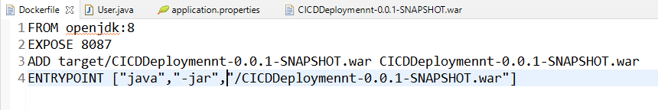

#### **Users.java**

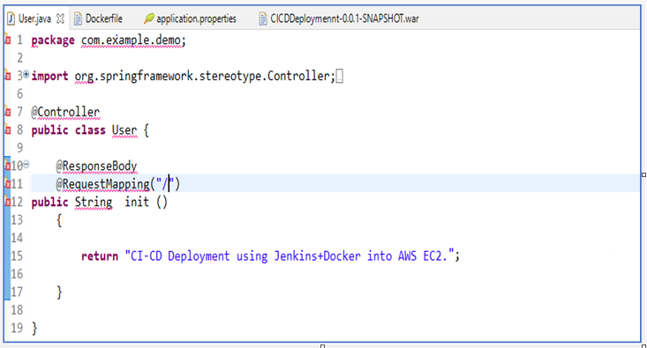

### **Application Properties**

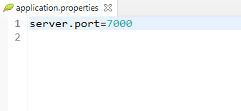

### **Pom.xml**

